How do you taste?

How do you taste your food? It is actually a lot more involved than just popping something in your mouth and eating it! Our bodies process so much information, more than you would ever imagine. The eyes are used to see if food looks appealing, if it is moldy, or what the consistency will be in our mouths. Our ears allow us to hear the crunch, the slurp and give our brains more information about our food than what is perceived in our mouths. Humans Our noses give us insight to what the food may ‘taste’ like. The tongue is responsible for ‘tasting’ the 5 basics tastes; sweet, sour, salty, bitter and umami (or savory).
What you will need:
- A mint or piece of candy (with no sugar/sour granules on the outside)
What you will do:
- Unwrap the candy or mint (but do not put it in your mouth).
- Plug your nose, so no air is flowing in or out of your nose (you can still breathe with your mouth).
- While plugging your nose, put the mint/candy in your mouth.
- While you are sucking on the candy, your brain wants to figure out what is in your mouth & your tongue is providing answers.
  - What is the texture or consistency?
  - Is it dry, liquid, gooey?
  - What is the temperature?
- Your tongue tastes the 5 basic tastes, but does not give any clues to what the ‘flavor’ is.
- Unplug your nose!
- POOF, you should have been able to detect the flavor almost instantly!
- Aroma from the food = flavor
- The aroma flows freely between your nose and your mouth, while in your nose the aroma compounds connect to a thin layer on the roof of your nose. Here it connects to an epithelium and sends signals to your brain with information about the food and flavor/aroma.
- Within seconds of unplugging your nose, you should know what the flavor of the food is! Pretty cool, right?

What’s happening?
Here are a few videos that help describe what’s happening:
- National Geographic: https://www.youtube.com/watch?v=Wa_WfcuE1a0
- TedEd Video to help explain what’s happening. https://www.ted.com/talks/rose_eveleth_how_do_we_smell/transcript?language=en#t-13488

Below is a pathway of eating and some of the things that are happening, simultaneously.

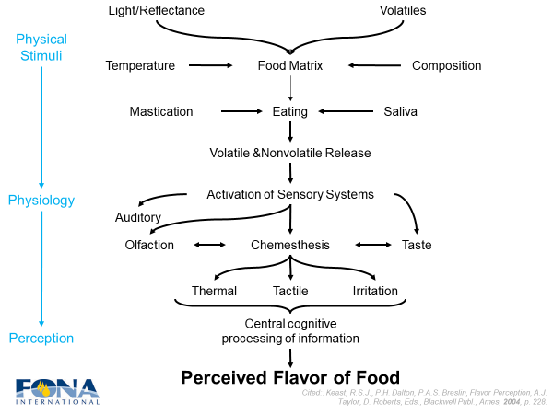

**Next Recommended Demonstration is: ‘Can you taste the rainbow?’ Demo

